**Term Paper**

**PREPARED BY-**

**Tahmid Asif Sadman**



ID:18101166

Section:04

**BRAC University**

Submission Date-30.9.2020

**Local Transportion Search Engine**

***Group-17***

|  |  |
| --- | --- |
| **Content** | **Page Number** |
| Introduction | 03 |
| System Proposal | 03 |
| System Request | 07 |
| Requirements | 07 |
| System Models | 09 |
| Conclusion | 14 |

**Introduction:**

There are different systems available for private transportation facilities but it mainly focuses on higher and higher middle-class people. However, in our project our target customers are the people who cannot afford private transportation facilities rather they prefer local transports. There are also cases where people require proper guidance for traveling in the local transport to save a lot of hassle and time. We are trying to make transportation more accessible, reducing congestion by getting more people on fewer available local transports. The main focus of this system is to manage and control public transports (Inter-city).

A Transportation Management System is a software system designed to manage transportation operations and ensure better transport service, decrease routing time with optimized cost and efficiency.

**A. System Proposal:**

**1. System Proposal (Project Charter)**

|  |  |
| --- | --- |
| **Project Name** | **Local Transportation Search Engine** |
| Creation date | 15/07/2020 |
| Project charter status |  |
| Project sponsor signature |  |
| Proposed project start date | 15/07/2020 |
| And end date | 30/09/2020 |

|  |  |
| --- | --- |
| Project Description | The Transport Management system will  include the following activities |
|  | 1) Transportation cost (Fair) estimation  -Assume fair based on selected stoppage  -suggest vehicles with minimal fair  -suggest sitting service vehicles  2) Data storage and sharing  -Archive of all vehicles and their possible  routes. |

|  |  |
| --- | --- |
|  | 3) Suitable Vehicle suggestions based on Route  Selection  - consumer will select his source and destination point, our software will suggest suitable vehicles that cover those routes. |
| Project Purpose | There is different system available for private transportation facilities but it mainly focuses on higher and higher middle-class people. However, in our project our target customers are the people who cannot afford private transportation facilities rather they prefer local transports. There are also cases where people require proper guidance for traveling in the local transport to save a lot of hassle and time. We are trying to make transportation more accessible, reducing congestion by getting more people on fewer available local transports. |
| Project goals and outcomes | The purpose of this system is to manage and control public transports (Inter-city). A  Transportation Management System is a software system designed to manage transportation operations and ensure better transport service, decrease routing time with optimized cost and efficiency. |
| Project scope | The project will include design, test and Web based system to help people find out available transports in affordable price and optimized roots for faster travelling. All hardware and software resources will be managed by the project group. Mainly we will focus on the Database design, schema design, web base UI platform design. We will focus on equivalence partition base testing, component testing and integrated system testing. The project is funded by the group member. The project will be completed by the end of the semester. |
| Features | One of the key features is users will know about trip details and they can find a list of available and suitable rides. Secondly, they can get an estimated fare for traveling a specific distance. In addition to that, it will help them to travel with optimal fare. Thirdly, it will inform the user regarding the multiple drop off points throughout the journey. Moreover, it will get numbers and analyze the data to rate local transports. Fourthly, the system will have online booking options. In conclusion, it will Help the user to find a suitable companion for traveling and to communicate with each other to make their journey comfortable and enjoying. In some case, it also helps to ensure a safe and secured ride specially for women, children and old people. |
| Users | The target market for our web base system is anyone who needs a short to mid-distance local transportation within the cities. Especially the men and women traveling frequently for work or business who needs a budget ride. One of our main focuses is the students who need an affordable and accessible transportation system. Especially, young girls get harassed in local buses most often, this system will provide security for them. So, while traveling to unknown routes It becomes harder for the normal students to afford other private riding facilities (Applications). And many of us are not aware of the student fare of different local transports. This system will notify them about these facilities. |
| Proposed Technology | Web based Platform, server, central database, user friendly web with cost estimation, dynamically updated data to ensure reliability. |
| Stakeholders | * Public transport Owners * Transport users * Government transport Authority (BRTA) * System Architect |
| Constraints | Limited secondary data available. Its time consuming to collect primary data. Less chances of open-ended interview for requirement collection from end users. Very few people are compatible with existing transportation applications so it will require time to make them familiar with our developed system. Frequent changes in local bus route require frequent changes in database which decreases the quality of program code. Limited time span to analyze and implement such a vast and dynamic project. Since there is no official sponsor, we will get less financial support. |

**B. System Request**

**Project Sponsor:** Project Manager

**Business need:** The project has been initiated to help majority of general people to search for Local transports and to notify them about minimum fair.

**Business Requirement:**

1. Search for preferable and optimum routes.

2. Search for suitable buses.

3. Compare between costs for different routes and can choose buses with minimal fair.

4. Able to know about Bus rating and review and can also rate buses and make constructive comment about buses.

5. Users can find online tickets depending on the ratings of their desired vehicle.

**Business value:**

1. Higher customer satisfaction due to less hassle.

2. People can save time as they don’t have to wait for random buses and ask others about suitable buses.

3. Higher customer satisfaction due to less hassle.

4. People can save time as they don’t have to wait for random buses and ask others about suitable buses.

5. We can reach out to new customers through internet support via online ticket system.

**Special issues or constraints:**

1. As most of our country’s lower middle-class people can’t comfortably use web-based service so in future we will try to introduce android based application with Bengali User Interface which will be more user friendly.

**1. Functional requirements:**

**A. Searching & Booking**

A.1 The user can search for desired vehicle.

A.2 The user can view a list of available vehicles.

A.3 The user can select optimal and suitable root to reach his destination.

A.4 The user can select different categories of buses.

A.5 The user can book tickets online and confirmation message will be sent to the user by Email or Phone number.

A.6 The user can choose source and destination location.

A.7 The user can view all the routes.

**B. Cost estimation**

B.1 The user can check the estimated fare for travelling a certain distance.

B.2 The users can compare between the fares.

B3. The system will suggest buses to travel at minimum cost.

B4. The user can perform payment in multiple mode such as cash, Bikash, rocket etc.

**C. Printing**

C.1 The user can print his/her online ticket.

C.2 The user can view a preview of the available roots before selecting.

**2. Nonfunctional requirements**

**A. Operational requirements:**

A.1 The system should be able to work in any web browser.

A.2 The system will operate in Windows environment.

**B. Performance requirements**

B.1 Response time should be less than 30 seconds.

B.2 The database will be updated every day.

B.3 The system should be available for use 24 hours.

**C. Security requirements**

C.1 Only admin can permit to change or add routes.

C.2 The system will guaranty customer’s information on source and destination confidential.

**D. Cultural and political requirements**

D.1 During strikes and political gatherings and rally some of the transports may not be available for general users.

D.2 Only the buses and routes verified by BRTA should be enlisted to our inventory.

**C. System Model:**

**C-1. Use Case Diagram:**

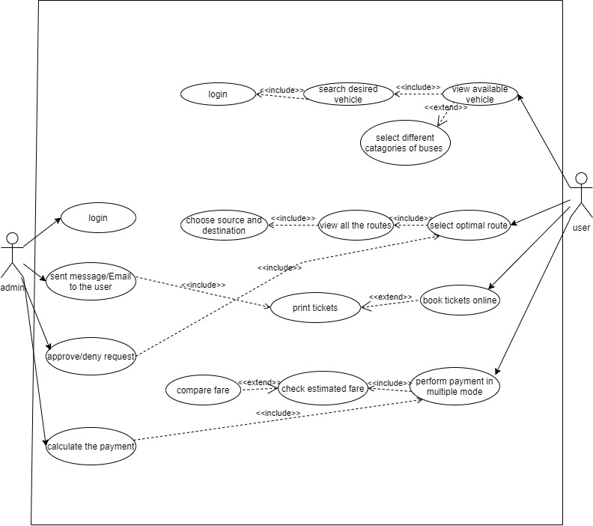

This use case represents one of our main functionalities. Here Primary actor is userand this is an essential detailed use case. This Use case describes how user searches based on different criteria. Moreover, Location-Search, Source-Destination search and vehicle wise-Search is participating in relationship with Search. The Normal Flow of Events includes- User inserts Source and Destination locations and it is matched with the corresponding database to make sure that vehicles exist for this specific valid route. In addition to that, it calculates estimated fare based on travelling distance and shows result to the user. User uses location search where user mentions the name of the location which he wants to visit and then system checks whether vehicles cover this point along with the point validity check. There is another sub flow which provides vehicle-wise search capability. User inserts his preferred vehicle type and system responds to that by generating data of given vehicles. Also, user can book online tickets and the system will send proof of online tickets via Email or messages.

**C-2. Class Diagram:**

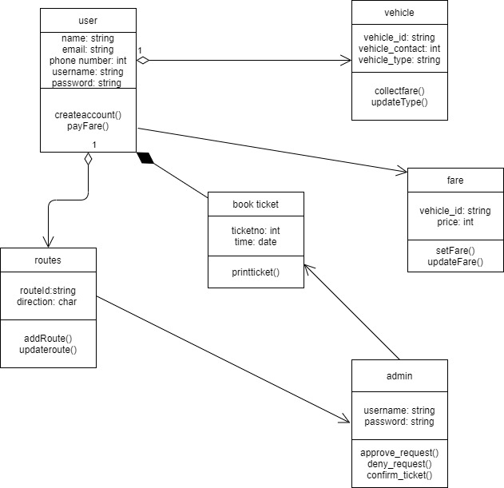

In the class diagram, both the user and admin will have username and password where the users will give information about themselves to create account. The user will also give request which will be associated by the admin. Vehicle and route class will directly aggregate with the user while book ticket class will compose because book ticket class cannot exist without the user. Fare class will determine the estimated fare directly to the user.

**C-3. Activity Diagram:**

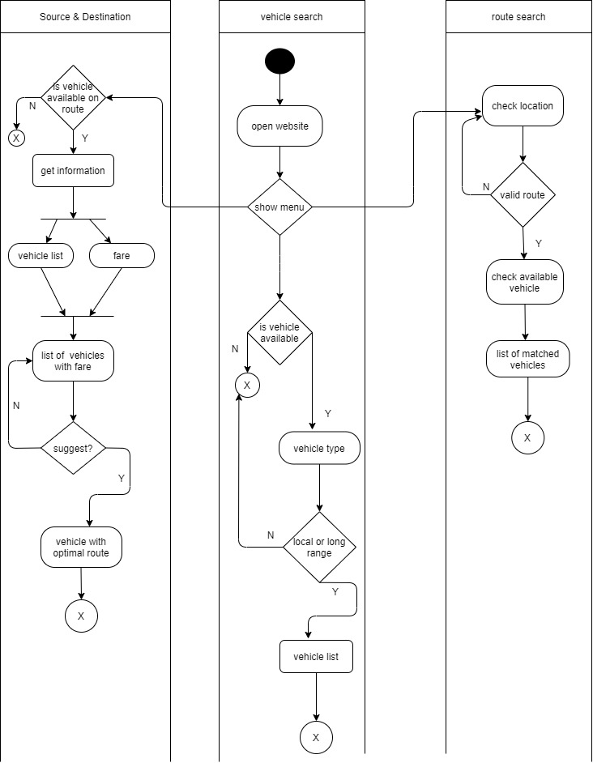

The user will begin his search from website where he will search for available vehicle, vehicle type and whether the user wants a local vehicle or a long range one. The show menu option will take user to check location where user will confirm his location and route. If users’ requirements satisfy, then a list of available vehicles will pop up. When users search for available routes, a fork node will create two options which is vehicle list and fare. The vehicle list will be found from route and vehicle lanes. After that both vehicle list and fare will join with a node and asks for suggestions with vehicle with optimal routes.

**C-4. Sequence Diagram:**

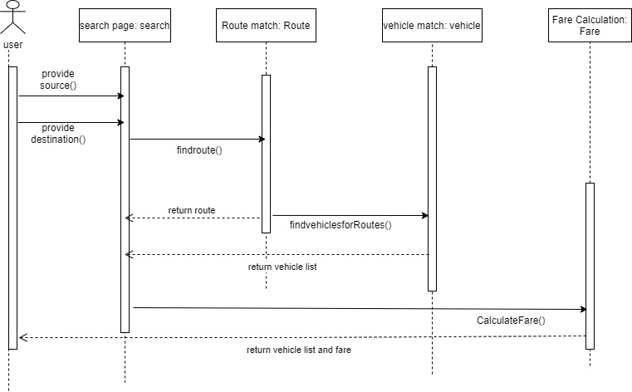

In Source Destination sequence diagram, we can see user will go to the Search page firstly. Then, Provide the Current Location and Destination information. Based on the information the system will find route from the database and return the route. At the same time the system will search for vehicle list for the route. If the vehicle lists are found it is then sent. Then, the route and vehicle list are sent to for calculating fare. Finally, the vehicle list will appear with the calculated fare to the user interface.

**C-5.1 Data Flow Diagram (Context Diagram):**

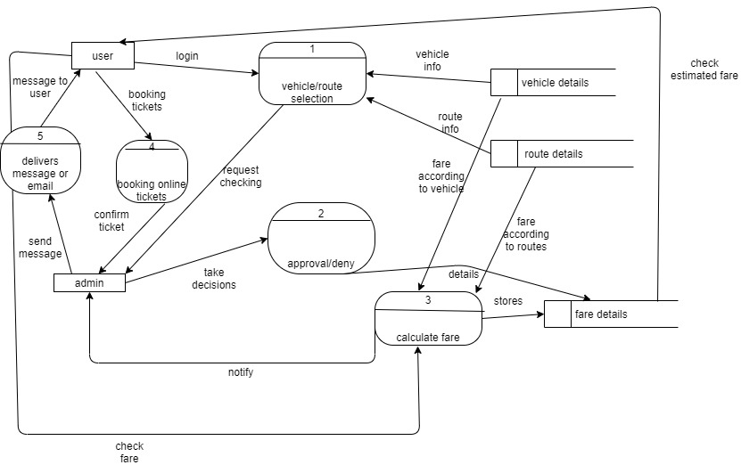

A data flow diagram (DFD) is a graphical representation of the movement of data between external entities, processes and data stores within a system. Simply put, DFD’s show how data moves through an information system. Here, user and admin are the external agents and vehicle, route, fare are three data stores whose primary job is to store data. Here, the user logins to select vehicle and routes in vehicle and route selection process which takes information from vehicle and route data store. After that, the admin will verify the users request through approve/deny process which will store the answer of admin in fare data store. The calculate fare process will take information from vehicle and route data store and with user’s requirements, it will calculate a fare which will be stored in fare data store. There are two more processes for online ticket system whose primary job is to take request from the user for online tickets and then the admin will send a copy of that online ticket to user via E-mail or message.

**C-5.2 Data Flow Diagram (Level 1 Diagram):**

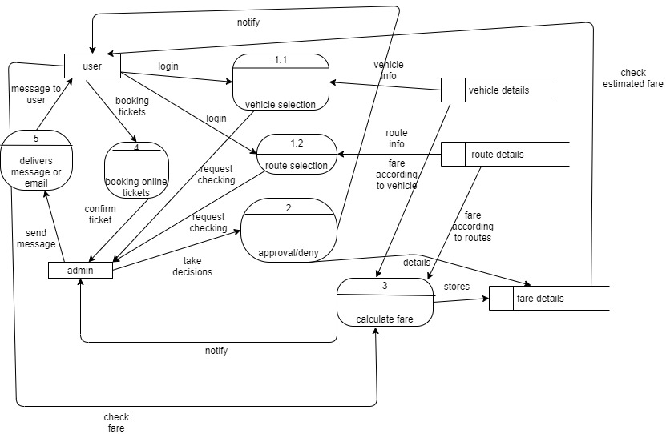

**D. Conclusion:**

Last but not the least, this project’s whole intention is to make those people’s lives easier who cannot afford private transportation facilities. Moreover, this project also focuses on those people who require guidance while transporting in the local transport to save a lot of hassle especially young girls who suffers the most in local transportation services every day. This project will make the transportation cozier and more accessible for many people. This project will ensure better transport operations and ensure better transport service, decrease routing time with optimized cost and efficiency.